**PM SHRI KENDRIYA VIDYALAYA BERHAMPUR**



SESSION 2024-25

**A Project Report On**

**CARE AND CURE**

**(SKIN AND HAIR CARE SYSTEM)**

**For**

**CBSE 2025 Examination**

[As a part of the Computer Science Course (083)]

**SUBMITTED BY : SUBMITTED TO:**

**(**ADISHREE DAS) **Mr. S. K. MISRA**

Class :XII APGT (Computer Science)

Roll NO:

**CERTIFICATE**

THIS IS TO CERTIFY THAT (YOUR NAME) STUDYING IN CLASS XII A, HAS SATISFACTORILY COMPLETED PROJECT WITH THE TITLE CARE AND CURE UNDER THE GUIDANCE OF Mr. SAROJ KANTA MISRA, PGT (COMPUTER SCIENCE) DURING THE ACADEMIC YEAR 2024-25 IN PARTIAL FULFILLMENT OF “COMPUTER SCIENCE” PRACTICAL EXAMINATION OF CENTRAL BOARD OF SECONDARY EXAMINATION (CBSE)

___________ ______________ Internal Examiner External Examiner

__________

PRINCIPAL

ACKNOWLEDGEMENT

I warmly acknowledge the continuous encouragement and timely suggestions offered by our Principal **Mr. SHIVAPRIYA DASH**. I extend my hearty thanks for giving me the opportunity to make use of the facilities available in the campus to carry out the project successfully.

I am highly indebted to **Mr. SAROJ KANTA MISRA**, (PGT Computer Science), for the constant supervision, providing necessary information and supporting in completing the project. I would like to express my gratitude towards them for their kind cooperation and encouragement.

Finally, I extend my gratefulness to one and all who are directly or indirectly involved in the successful completion of this project work.

Name:

Sign:

Class XII**-**A

**CONTENTS**

## Introduction

1. **System Implementation**
   1. The Hardware used:
   2. The Software’s used:

## System Design & Development

* 1. Python Coding
  2. Database
  3. Output Screen

## References

**INTRODUCTION**

**CARE AND CURE**

In today’s world, the abundance of skincare and health care products can often be overwhelming, making it difficult for individuals to select the right products suited to their unique skin and health needs. Each person’s skin and body type is different, and with a variety of conditions ranging from acne and dry skin to sensitive skin or aging concerns, a one-size-fits-all approach is not always effective.

This project aims to provide a tailored solution by helping individuals choose the most appropriate skin and health care products based on their specific needs. Through an in-depth analysis of common skin and health concerns, this project will offer personalized recommendations, ensuring that users can confidently select products that will benefit them the most. By understanding the underlying causes of different skin issues and health conditions, we seek to optimize product effectiveness, improve health outcomes, and help individuals maintain their well-being with products suited to their unique profiles.

Our goal is to demystify the process of selecting the right skincare and health products, offering scientifically-backed advice to enhance the overall skin and health care experience.

This project is your ultimate guide to unlocking the secret of flawless skin and optimal health. No more guesswork. No more trial and error. We’re bringing you a revolutionary way to discover exactly which products your skin and health deserve. Whether you're dealing with stubborn acne, dry patches, or are looking for an anti-aging miracle, we’ve got you covered with personalized, science-backed recommendations that are as unique as you are.

Imagine having the power to confidently choose products that actually work for your specific needs. This project is designed to help you navigate through the overwhelming maze of beauty and wellness products, cutting through the noise to present only what’s best for you. By understanding your skin’s and body’s specific concerns, we’ll make sure every product recommendation is a perfect match—transforming your skincare and health routine into a tailored experience that works!

Gone are the days of wasted time and money on products that don’t live up to their promises. With our expertly curated solutions, you’ll achieve healthier, radiant skin and a thriving body—all with the confidence that you’re using the products that are perfect for you.

Step into a new era of skincare and wellness—where you are the priority. Say goodbye to confusion and hello to the healthy, glowing skin and vibrant health you’ve always deserved!



* Python is a high-level language. It is a free and open- source language.
* It is an interpreted language, as Python programs are executed by an interpreter.
* Python programs are easy to understand as they have a clearly defined syntax and relatively simple structure.
* Python is case-sensitive. For example, NUMBER and number are not same in Python.
* Python is portable and platform independent, means it can run on various operating systems and hardware platforms.
* Python has a rich library of predefined functions.
* Python is also helpful in web development. Many popular web services and applications are built using Python
* Python uses indentation for blocks and nested blocks.

**System Implementation**

**Hardware used:**

While developing the software, the used hardware’s are: PC with Intel Core i3 processor having 4.00 GB RAM and other required devices.

**Software used:**

* Microsoft Windows® 10 as Operating System.
* Python IDLE as Front-end Development environment.
* CSV Files as Back-end for storing the data.
* MS-Word 2010 for documentation.

**Python Coding:**

import mysql.connector as l

#TO SEARCH THE PROBLEMS ACCORDINGLY

defsearchprob():

try:

prob=l.connect(host="localhost",user="root",password="admin",database="carecure")

cur=prob.cursor()

problem=input("enter the problem")

cur.execute("select * from hair,skin where problems like '%{}%' and skin.problems=hair.problems ".format(problem))

du=cur.fetchall()

print("~~~~ WE ARE HERE TO GIVE YOU THE SOLULU FOR YOUR PROBLULU ~~~~")

print("products as per your search")

print(du)

prob.commit()

except:

print("error found ")

print("give the input again ")

searchprob()

#TO SHOW THE HAIR PROBLEM OF THE FOLLOWING

defhairprob():

try:

hprob=l.connect(host="localhost",user="root",password="admin",database="carecure")

cor=hprob.cursor()

t=input("enter the hair problem ")

cor.execute("select * from hair where problems like '%{}%' ".format(t))

print("~~~~ WE ARE HERE TO GIVE YOU THE SOLULU FOR YOUR PROBLULU ~~~~")

g=cor.fetchall()

for i in g:

print("your problem is :",i[0])

print("the soulution to your problem is ==",i[1])

print("you must avoid : ",i[2])

print("the suggestions ",i[3])

hprob.commit()

except:

print("error found")

hairprob()

#TO SHOW THE SKIN PROBLEMS SOLUTIONS

defskinprob():

try:

skprob=l.connect(host="localhost",user="root",password="admin",database="carecure")

sor=skprob.cursor()

t=input("enter the skin problem ")

sor.execute("select * from skin where problems like '%{}%'".format(t))

print("~~~~ WE ARE HERE TO GIVE YOU THE SOLULU FOR YOUR PROBLULU ~~~~")

g=sor.fetchall()

for i in g:

print("your problem is :",i[0])

print("the soulution to your problem is ==",i[1])

print("you must avoid : ",i[2])

print("the suggestions ",i[3])

skprob.commit()

except:

print("eroor found ")

print("input agan")

skinprob()

defchangessuggestion(x):

try:

sub=l.connect(host="localhost",user="root",password="admin",database="carecure")

sbor=sub.cursor()

sbor.execute("select * from subscription")

k=input("enter the #")

if k=="#":

l=input("enter the suggestion here:")

sbor.execute("update subscription set suggestion='{}'where name='{}'".format(x,l))

sub.commit()

else:

print("invalid input enter again")

changessuggestion()

except:

print("error found")

changessuggestion()

#TO CHANGE THEIR OWN SUGGESTION AND CHANGE THEIR PROBLEMS

def subscription():

try:

sub=l.connect(host="localhost",user="root",password="admin",database="carecure")

sbor=sub.cursor()

sbor.execute("select * from subscription")

subs=sbor.fetchall()

print("if already in subscription print *")

print("want to join the subscription print^")

v=input("enter your choice")

if v=='*':

a=input("enter the name of the user:")

b=input("enter the password")

for i in subs:

if i[0]==a and i[1]==b:

print("write the things you want to suggest in which feild ")

print("if you want to recommend your products send us the email us in care&cure@gmail.com")

print("or you can email us personally in dasadishree15@gmail.com OR itishree@gmail.com ")

j=input("enter the product name :")

h=input("enter your feedback:")

print("you have previously suggested to",i[2])

print("hope you are seeing some changes in our website if it is not visible we are sorry for your dissappointment we are working on it ")

print("thank you for your suggestion we are so glad to have a customer like you ")

print("want to change your suggestion click #")

changessuggestion(a)

else:

print("wrong combination of user and passwod ")

subscription()

elif v=="^":

print("HEY POOKIE want to have the subscription !!")

print("let us tell you what this page is exactly")

print("here you can send us the sample of your product then we analyse your products and then we will suggest your products accordingly")

print("and then after your product is shown in any of our problems we will send you price accordingly")

s=input("enter your name :")

v=input("enter your password (password must contain 4 elements):")

q=input("enter the suggestion:")

sbor.execute("insert into subscription values('{}','{}','{}')".format(s,v,q))

sub.commit()

subscription()

except KeyboardInterrupt:

print(" unknown error occured ")

subscription()

except :

print("error found")

subscription()

#FOR THE OWNWER

defownerlogin():

try:

own=l.connect(host="localhost",user="root",password="admin",database='carecure')

owno=own.cursor()

owno.execute("select * from the ownerlogin")

owne=owno.fetchall()

a= input("enter the name ")

b=input("enter the security code :")

owner=owno.fetchall()

for i in owner:

if i[0]==a and i[1]==b:

print("~~~~~~~")

print("HELLO MY CREATER , THANK YOU FOR MAKING ME ")

print("~~~~~~~")

print("May I help you with anything or you want to change something")

print('whatever you want to change , i will accept it ')

print("what you problems solution or suggestion you want to change ")

c=input("enter the problem you want to change:")

d=input("select where you want to change (skin,hair):")

e=input("enter what you want to change (suggested_products/solutions/avoid) :")

f=input("enter the change:")

if d=="skin":

if e=="suggested_products":

owno.execute("update skin set suggested_products='{}' where problems='{}'".format(f,c))

own.commit()

elif e=="solutions":

owno.execute("update skin set solutions='{}' where problems='{}'".format(f,c))

own.commit()

elif e=="avoid":

owno.execute("update skin set avoid='{}' where problems='{}'".format(f,c))

own.commit()

else:

print("enter the words exactly as written their")

own.commit()

ownerlogin()

elif d=="hair":

if e=="suggested_products":

owno.execute("update hair set suggested_products='{}' where problems='{}'".format(f,c))

own.commit()

elif e=="solutions":

owno.execute("update hair set solutions='{}' where problems='{}'".format(f,c))

own.commit()

elif e=="avoid":

owno.execute("update hair set avoid='{}' where problems='{}'".format(f,c))

own.commit()

except:

print("error found")

ownerlogin()

#TO SHOW THE PREVIOUS PROBLEM OF THE USER

defpreviousprob():

try:

pr=l.connect(host="localhost",user="root",password="admin",database="carecure")

por=pr.cursor()

global x

global y

por.execute("select stype,htype,skinproblems,hairproblems from login where username = '{}' and password = '{}'".format(x,y))

q=por.fetchall()

print("your skin type is :",q[0])

print("your hair type is :",q[1])

print(" your previous skin problem was:",q[2])

print("your previous hair problem was : ",q[3])

print("~~~~ we are so glad that you shared your problems with us ~~~~")

print(" ~~~ i hope your problems are healing ~~~~~~")

print("~~~ REMEBER ALL SKINS ARE BEAUTIFUL ~~~")

Z=input("enter $ to show add another problem OR if you want to end print anything else:")

if Z=="$":

type=input("enter which type of problem (hair or skin):")

if type=="hair" :

problem=input("enter the new problem here:")

por.execute("update login set hairproblems='{}' from login where username='{}' and password='{}' ".format(problem,x,y))

pr.commit()

pr=l.connect(host="localhost",user="root",password="admin",database="carecure")

por=pr.cursor()

por.execute("select stype,htype,skinproblems,hairproblems from login where username = '{}' and password = '{}'".format(x,y))

q=por.fetchall()

print("your skin type is :",q[0])

print("your hair type is :",q[1])

print(" your previous skin problem was:",q[2])

print("your previous hair problem was : ",q[3])

pr.commit()

elif type=="skin":

problem=input("enter the new problem here:")

por.execute("update login set hairproblems='{}' from login where username='{}' and password='{}' ".format(problem,x,y))

pr.commit()

pr=l.connect(host="localhost",user="root",password="admin",database="carecure")

por=pr.cursor()

por.execute("select stype,htype,skinproblems,hairproblems from login where username = '{}' and password = '{}'".format(x,y))

newq=por.fetchall()

print("your skin type is :",q[0])

print("your hair type is :",q[1])

print(" your previous skin problem was:",q[2])

print("your previous hair problem was : ",q[3])

pr.commit()

else:

pr.commit()

except NameError :

print(" wrong user or paasword")

except:

print("error found")

# TO CONTINUE THE LOOP THE MAIN WEBSITE

def continues():

while True:

try:

print("--------*****-------")

print("~~~~~~WELCOME TO CARE AND CURE~~~~~~")

print("--------*****-------")

print(" ~~~THIS IS A WEBSITE TO SOLVE YOUR PROBLEMS~~~")

print("~~AS WE ALL ARE AWARE OF THE FACT THAT THERE ARE LOTS OF WEBSITE , LOTS OF PRODUCTS IN THE MARKET OF DIFFERENT COMPANY~~ ")

print(" .... SO HOW CAN WE KNOW WHICH PRODUCT IS BEST FOR OUR SKIN OR HAIR AS WE CANNOT DO EXPERIMENT IN OUR BODY .... ")

print("do not need to be worry about it we are here to tell you which product from which company is best for you so you do not need to do experiments with your body")

print("choose the options accordingly:")

print(" 0 for search:")

print("1 for hair problem")

print("2 for skin problem")

print("4 for exit")

print("3 for showing the previous problems")

print("5 for the subscription:")

print("6 for the main website owner login:")

l=int(input("choose the option:"))

if l==0:

searchprob()

elif l==1:

hairprob()

elif l==2:

skinprob()

elif l==3:

print(" HELLO ")

print("I hope your skin is healing with your previous problems ")

print("ndi also hope your hair problems are also cured")

print("i know your skin, hair must love our suggestions <3")

previousprob()

elif l==4:

print("thank you pls visit again <<3")

return l

elif l==5:

print("if already in subscription print *")

print("want to join the subscription print^")

subscription()

elif l==6:

ownwerlogin()

except ValueError:

print("************",end="")

print("OOPSS WRONG INPUT PLEASE ENTER A INTEGER WITHIN 0 TO 6",end="")

print("************")

continues()

finally:

print("~~~~~~ AAPKA HUKUM SARAKHON PAR MERE AAKA ~~~~~~")

print("~~~~FOR MORE DETAILS CONTACT US IN care&cure@gmail.com.in WE ARE ALWAYS THERE FOR YOU ~~~~~~")

print("_____YOUR PROBLEMS ARE NOT ONLY YOUR PROBLEMS IT'S OURR PROBLEM TOO_____")

#TO LOGIN THE USER

def login():

try:

s=l.connect(host="localhost",user="root",password="admin",database="carecure")

x=input("enter un:")

y=input("enter password:")

co=s.cursor()

co.execute("select * from login")

jh=co.fetchall()

for i in jh:

if i[0]==x and i[1]==y:

a=continues()

if a==4:

return x and y

break

#end

else:

print("----------NEW USER----------")

print("welcome to our website please creat your new id")

b=input("enter the user name ( the username must contain 8 characters maximum) :")

p=input("enter a password(it should be equal or less than 6 characters)==")

h=input("what is your skin type:oily,normal,dry==")

print("you can check your hair type by this process_________take a hair strand and put it in a glass of water : if it floats then your hair is low porosity hair type/___if your hair shink in water then your hair type is high porosity/____if it neither float nor shink in water then your hair type is medium porosity ")

print("enter your hair type as medium,low,high==")

f=input("what is your hair type:")

r=input("hprob")

j=input("enter your skin problems:")

co.execute("insert into login values('{}',{},'{}','{}','{}','{}')".format(b,p,h,f,r,j))

s.commit()

login()

except:

print(" the password must contain 6 characters max")

print('the user name should be 8 characters')

login()

login()

**Output (Screenshots):**

**enter un:adi**

**enter password:2008**

**--------*****-------**

**~~~~~~WELCOME TO CARE AND CURE~~~~~~**

**--------*****-------**

**~~~THIS IS A WEBSITE TO SOLVE YOUR PROBLEMS~~~**

**~~AS WE ALL ARE AWARE OF THE FACT THAT THERE ARE LOTS OF WEBSITE , LOTS OF PRODUCTS IN THE MARKET OF DIFFERENT COMPANY~~**

**.... SO HOW CAN WE KNOW WHICH PRODUCT IS BEST FOR OUR SKIN OR HAIR AS WE CANNOT DO EXPERIMENT IN OUR BODY ....**

**do not need to be worry about it we are here to tell you which product from which company is best for you so you do not need to do experiments with your body**

**choose the options accordingly:**

**0 for search:**

**1 for hair problem**

**2 for skin problem**

**4 for exit**

**3 for showing the previous problems**

**5 for the subscription:**

**6 for the main website owner login:**

**choose the option:1**

**enter the hair problem dandruff**

**~~~~ WE ARE HERE TO GIVE YOU THE SOLULU FOR YOUR PROBLULU ~~~~**

**your problem is : dandruff**

**the soulution to your problem is == use oil on regular basis**

**you must avoid : avoid sharing your hair brush**

**the suggestions use minimalist anti dandruff serium**

**~~~~~~ AAPKA HUKUM SARAKHON PAR MERE AAKA ~~~~~~**

**~~~~FOR MORE DETAILS CONTACT US IN care&cure@gmail.com.in WE ARE ALWAYS THERE FOR YOU ~~~~~~**

**_____YOUR PROBLEMS ARE NOT ONLY YOUR PROBLEMS IT'S OURR PROBLEM TOO_____**

**--------*****-------**

**~~~~~~WELCOME TO CARE AND CURE~~~~~~**

**--------*****-------**

**~~~THIS IS A WEBSITE TO SOLVE YOUR PROBLEMS~~~**

**~~AS WE ALL ARE AWARE OF THE FACT THAT THERE ARE LOTS OF WEBSITE , LOTS OF PRODUCTS IN THE MARKET OF DIFFERENT COMPANY~~**

**.... SO HOW CAN WE KNOW WHICH PRODUCT IS BEST FOR OUR SKIN OR HAIR AS WE CANNOT DO EXPERIMENT IN OUR BODY ....**

**do not need to be worry about it we are here to tell you which product from which company is best for you so you do not need to do experiments with your body**

**choose the options accordingly:**

**0 for search:**

**1 for hair problem**

**2 for skin problem**

**4 for exit**

**3 for showing the previous problems**

**5 for the subscription:**

**6 for the main website owner login:**

**choose the option:2**

**enter the skin problem acne**

**~~~~ WE ARE HERE TO GIVE YOU THE SOLULU FOR YOUR PROBLULU ~~~~**

**your problem is : acne**

**the soulution to your problem is == If you have acne prone skin, wash twice daily & use a toner & moisturiser suited to your skin type. Foaming cleansers & oil-free moisturisers are recommended. You can use a black head removal scrub for exfoliation**

**you must avoid : Avoid touching & picking as it may cause scars**

**the suggestions use minimalist salicylic acid serium**

**~~~~~~ AAPKA HUKUM SARAKHON PAR MERE AAKA ~~~~~~**

**~~~~FOR MORE DETAILS CONTACT US IN care&cure@gmail.com.in WE ARE ALWAYS THERE FOR YOU ~~~~~~**

**_____YOUR PROBLEMS ARE NOT ONLY YOUR PROBLEMS IT'S OURR PROBLEM TOO_____**

**--------*****-------**

**enter un:lali**

**enter password:2870**

**--------*****-------**

**~~~~~~WELCOME TO CARE AND CURE~~~~~~**

**--------*****-------**

**~~~THIS IS A WEBSITE TO SOLVE YOUR PROBLEMS~~~**

**~~AS WE ALL ARE AWARE OF THE FACT THAT THERE ARE LOTS OF WEBSITE , LOTS OF PRODUCTS IN THE MARKET OF DIFFERENT COMPANY~~**

**.... SO HOW CAN WE KNOW WHICH PRODUCT IS BEST FOR OUR SKIN OR HAIR AS WE CANNOT DO EXPERIMENT IN OUR BODY ....**

**do not need to be worry about it we are here to tell you which product from which company is best for you so you do not need to do experiments with your body**

**choose the options accordingly:**

**0 for search:**

**1 for hair problem**

**2 for skin problem**

**4 for exit**

**3 for showing the previous problems**

**5 for the subscription:**

**6 for the main website owner login:**

**choose the option:4**

**thank you pls visit again <<3**

**~~~~~~ AAPKA HUKUM SARAKHON PAR MERE AAKA ~~~~~~**

**~~~~FOR MORE DETAILS CONTACT US IN care&cure@gmail.com.in WE ARE ALWAYS THERE FOR YOU ~~~~~~**

**_____YOUR PROBLEMS ARE NOT ONLY YOUR PROBLEMS IT'S OURR PROBLEM TOO_____**

**MY SQL DATABASE**

User- root

Password – admin

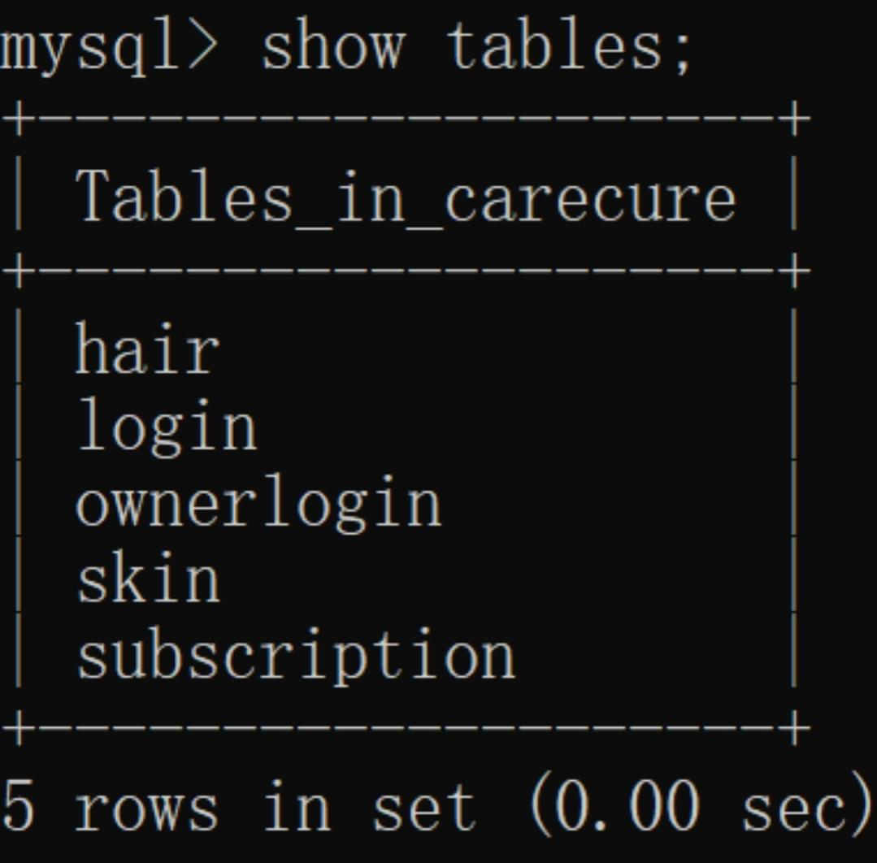Database Name— CARECURE

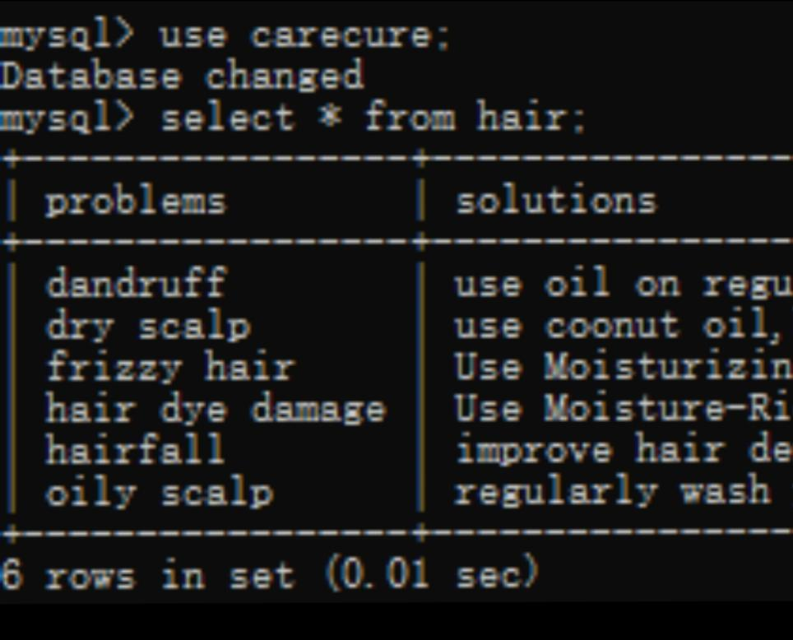HAIR TABLE

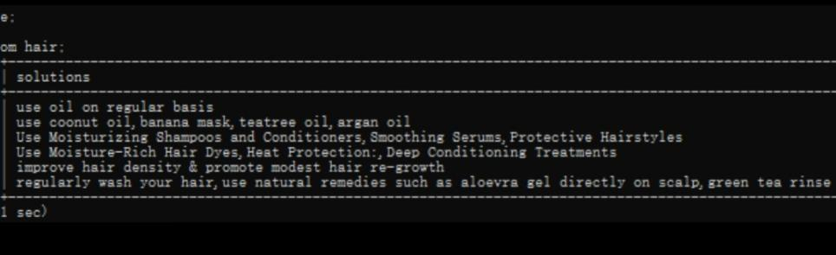

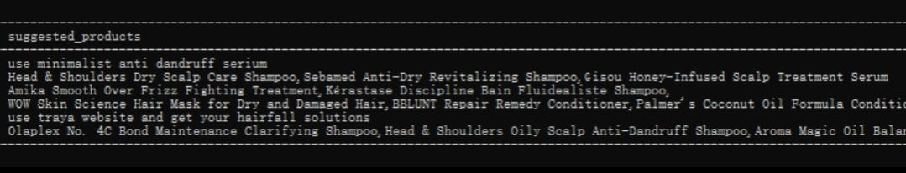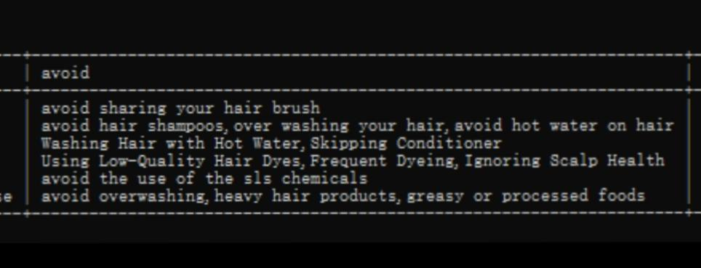

Login Table

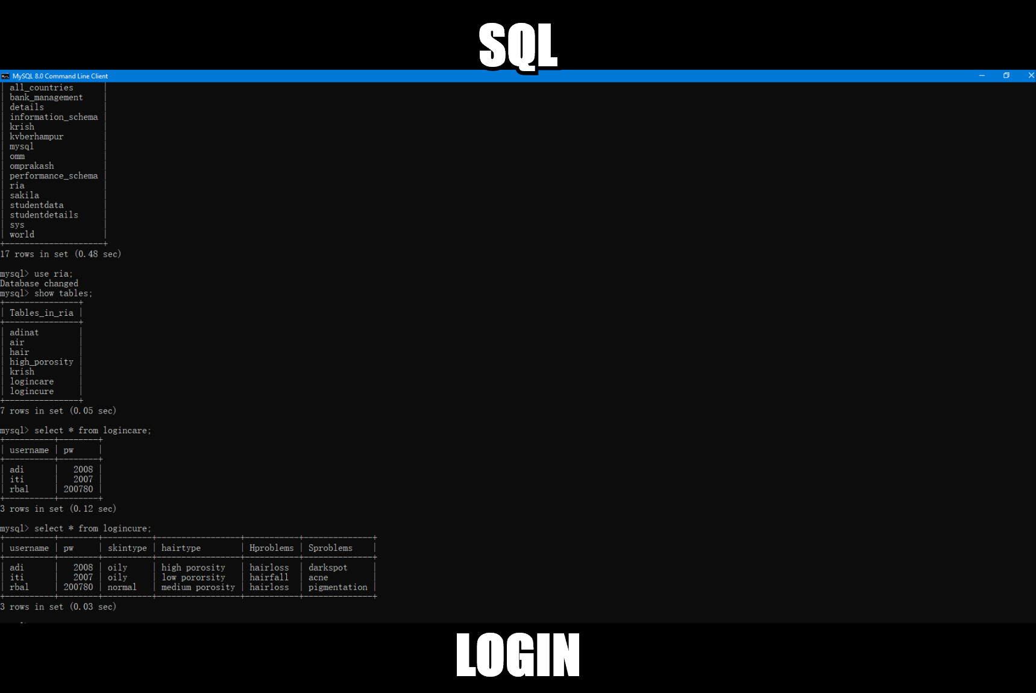

Owner Login TABLE

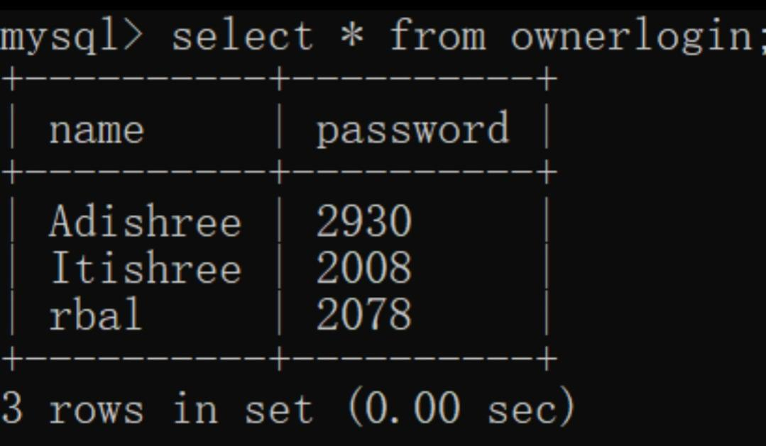

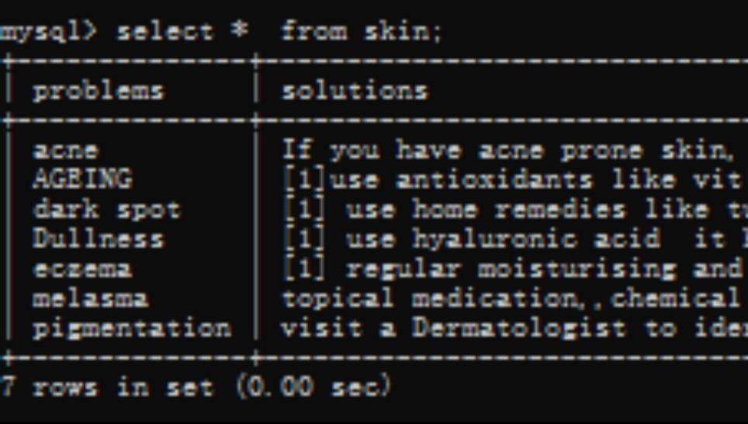SKIN TABLE

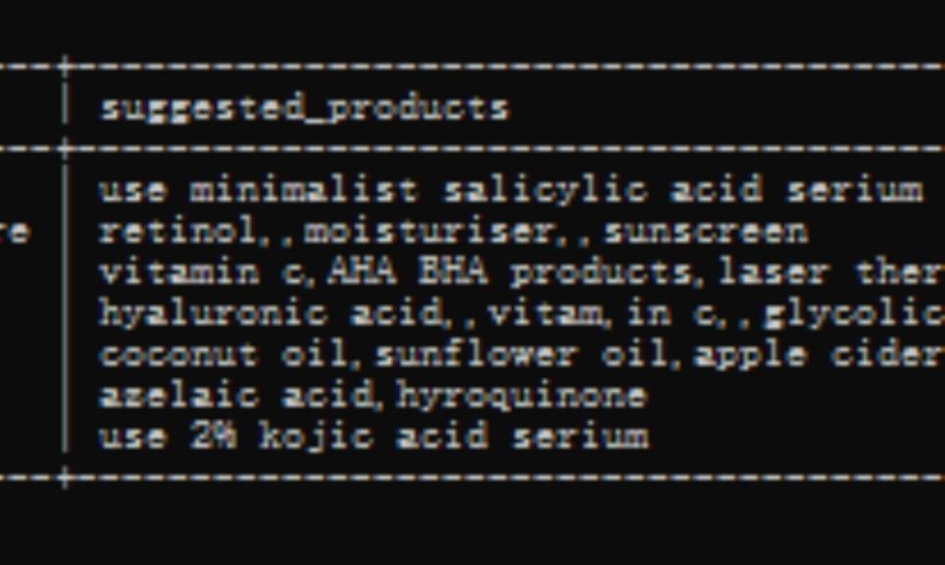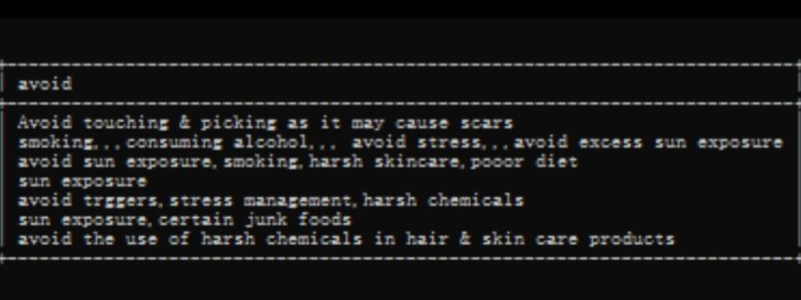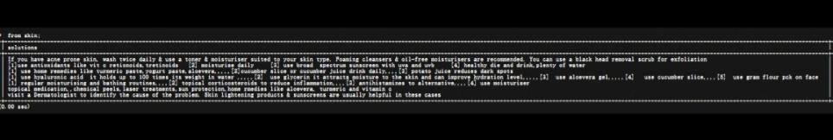

SUBSCRIPTION TABLE

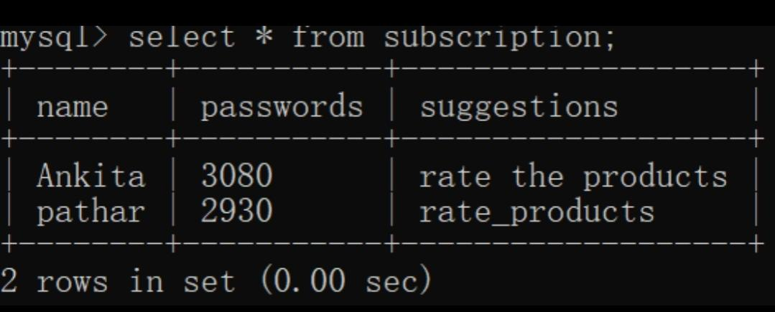

**References**

In order to work on this project titled –**Educational Technology(EdTech)**, the following books and websites are referred by me during the various phases of development of the project.

1. Informatics Practices (NCERT Class XI and XII)
2. Together with Informatics Practices
3. www.youtube.com
4. www.python.com

Other than the above-mentioned books, the suggestions and supervision of my teacher and my class experience also helped me to develop this software project.